
AMERICAN INTERNATIONAL UNIVERSITY-BANGLADESH
Faculty of Science and Technology
Department of Computer Science
CSC 3215: Web Technologies

Semester: Summer 2025-26 | Group No: |  | Section: | N

Group Members:
SL. | Student ID | Name | Role | Signature
1 | 23-52508-2 | NUR E MUDDASSIR TANIM | Group Leader
2 | 23-52890-2 | Anika Tahsin Arshi | Member
3 | 23-50814-1 | Minhajul Karim Eram | Member
Project Title
AIUB Lost and Found Portal
Short Description
The Aiub lost and found portal is a web application that lets university students report lost or found items. That means searching a live campus, white listing, and securely claiming recovered items through a verification-basedShe approval process. Instead of relying on scattered Facebook posts or a paper logbook at the security desk. Students can report an item once, and the system takes over. It lists the item publicly, automatically suggests likely matches between Lost and found reports, and routes the claim through a simple approve or reject workflow before any contact information changes hands. The system is built with HTML, CSS, JavaScript, PHP, and MySQL and supports three user types: guest, student, and admin, each with a distinct set of capabilities.
Introduction
Losing a personal item on a university campus an ID card, a calculator, a textbook, a phone which is a common but disproportionately stressful experience for students. Since these items are often needed for the very next class or exam. At the same time, whoever finds the item usually has no reliable channel to return it beyond handing it to a staff member or posting a photo in an unofficial Facebook group, where it is quickly buried under unrelated posts. This project addresses that gap with a purpose-built web portal where lost and found reports live in one searchable, permanent place.
The system is designed around three goals: (1) make reporting an item as fast as filling out a short form, (2) make finding a matching report faster than manually scrolling through a social media feed, and (3) add a lightweight verification step so that items are not handed over to the wrong person. The proposed platform targets university students as end users and campus security/administration as the moderating authority.

Background Study
Currently, most Bangladeshi university campuses handle lost and found items through one of three informal channels: a physical logbook kept at the security or admin office, word-of-mouth, or an unofficial Facebook group where students post photos of lost or found items. Each of these has clear limitations. A physical logbook is not searchable, is only accessible during office hours, and depends entirely on students knowing it exists. Facebook groups are searchable in theory but not in practice posts scroll out of view within hours, there is no structured way to filter by category or location. There is no formal claim/verification mechanism, which creates a risk of items being claimed by the wrong person.
"Lost and found” web platforms do exist for some airports, transit systems, and a handful of foreign universities, and they generally follow a common pattern: a public listing of found items, a search/filter interface, and a claim process gated behind some form of ownership verification. However, this pattern has not been adapted for the specific context of a Bangladeshi university campus, where the item categories (ID cards, calculators, and department-specific equipment or personal stuff), the reporting audience (students and campus security), and the trust model (verification questions rather than formal ID checks) are all different from a large public transit system. This project's background study therefore does not aim to copy an existing product, but to apply the general lost-and-found system pattern — report, list, match, verify, claim—to a campus-specific setting that currently has no dedicated tool at all.
ER Diagram

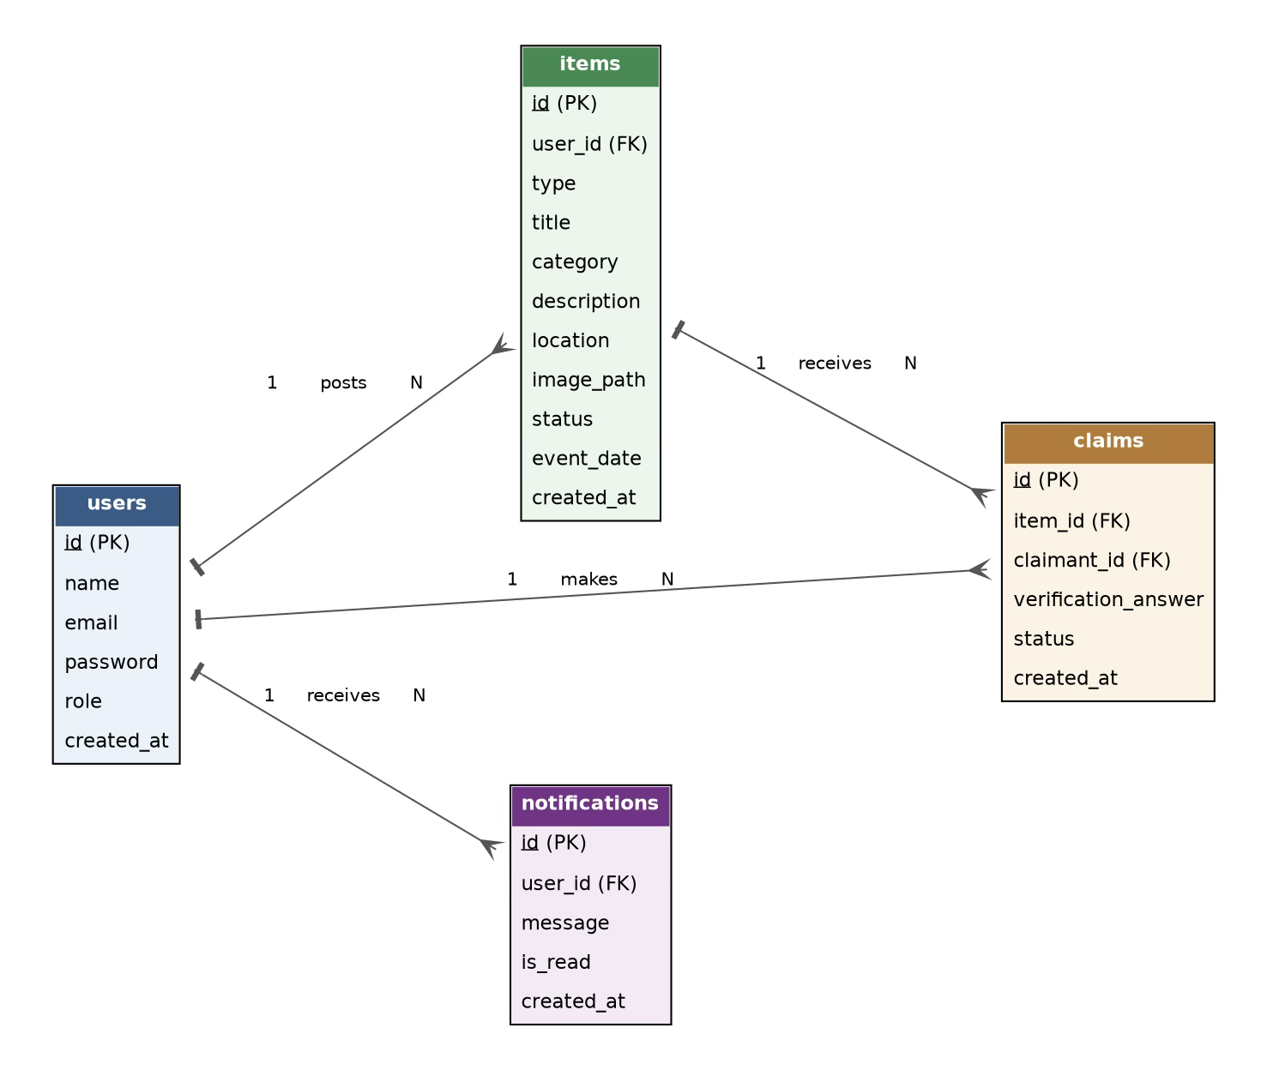

Use Case Diagram:
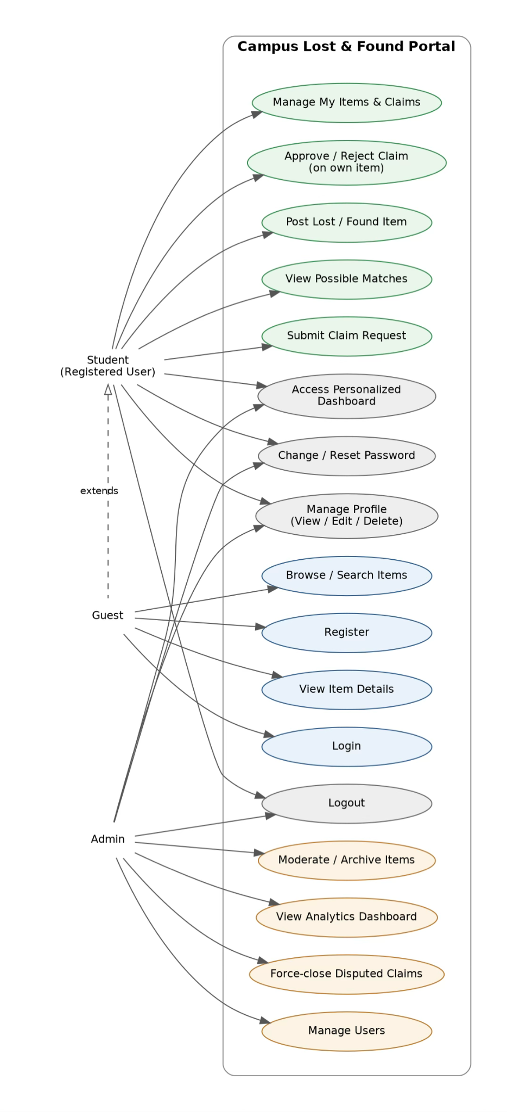

UI (Figma/Sketch)
1. Home and Browse Feed
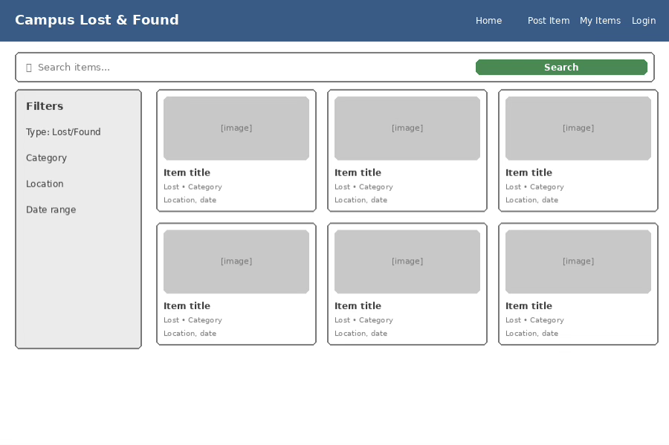
2. Post for Lost and Found items:

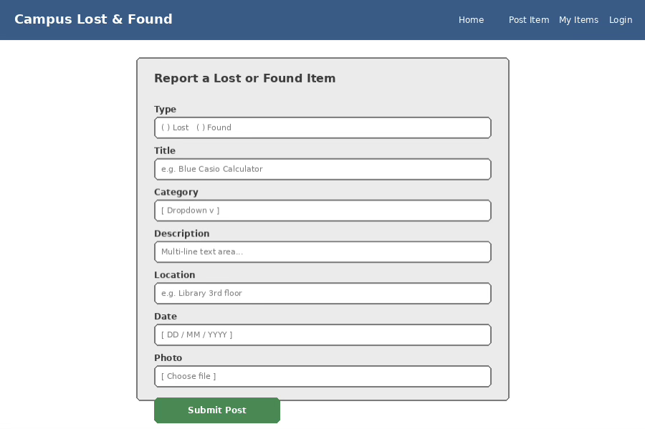

3. Item Detail Page:

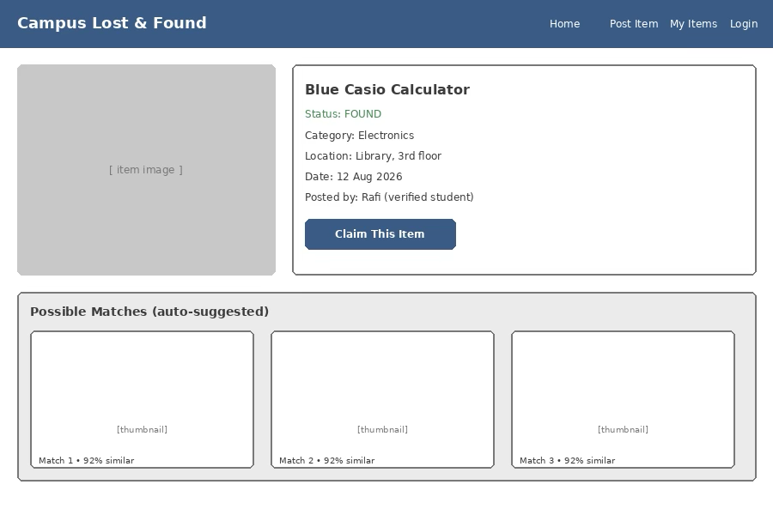
4. Profile and Account Settings:

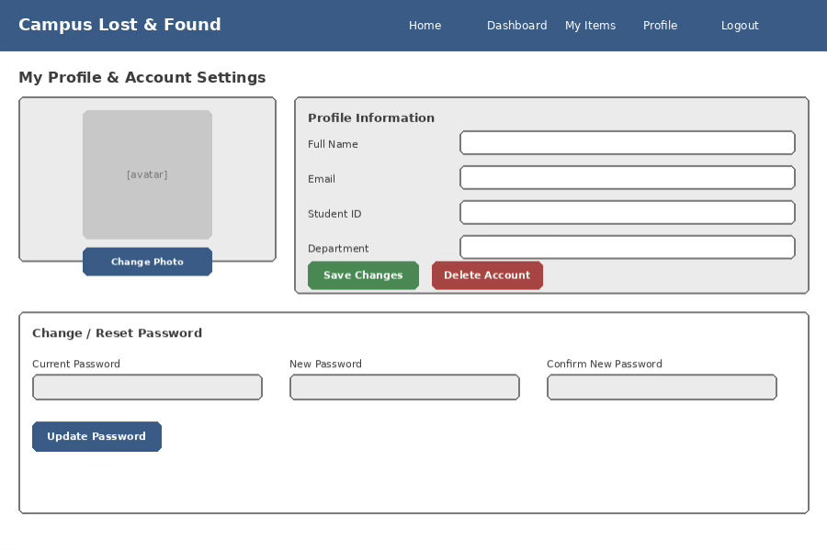

5. Admin Dashboard:

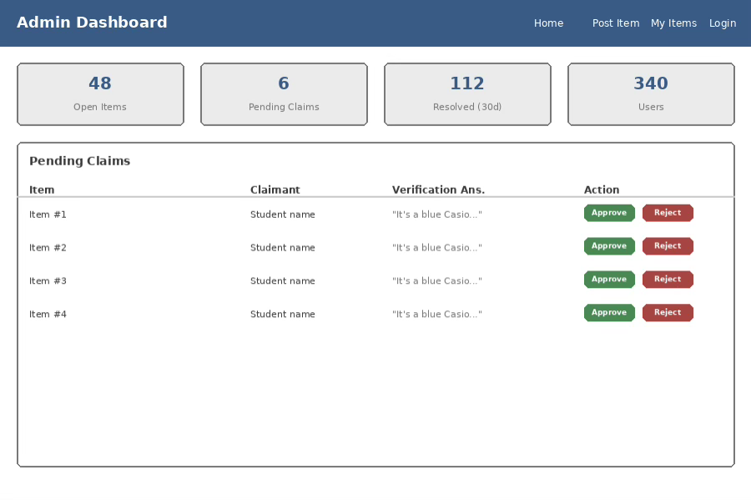
6. Personalized Dashboard:
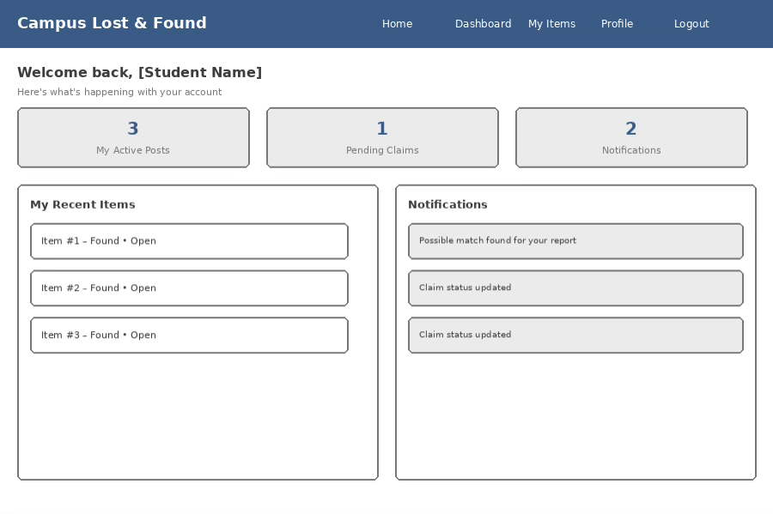

Types of User: 1. Admin 2. Student 3. Guest
Common Features (Available to All Users)
- Authentication
- Log in to the system
- Log out from the system
- User registration
- Account Management
- Change or reset password
- Manage profile information (view, edit, delete)
- Dashboard
- Access a personalized dashboard after login
Specific Features by User Type
- Features of Admin -
- Approve or reject claim requests
- Moderate / archive stale or spam listings
- View analytics dashboard
- Force-close disputed or abandoned claims
- Features of Student -
- Post a lost or found item with photo
- View auto-suggested “possible matches”
- Submit a claim with a verification answer
- Track own posted items & submitted claims
- Features of Guest(Not logged In) -
- Browse & search lost/found items
- View full item details
- Register / log in to unlock student actions

